DentTime Machine Learning Pipeline System Report
Document Overview:
This report outlines the end-to-end architecture, automation roadmap, data drift detection strategies, and the deployment lifecycle for the DentTime Machine Learning pipeline. The design balances immediate operational safety with a clear upgrade path toward fully automated, progressive MLOps capabilities.

1. System Workflow Architecture
The DentTime ML pipeline is divided into five distinct phases: Data, Training, Evaluation, Deployment, and Monitoring. The flow ensures robust data preparation, model validation, and continuous tracking.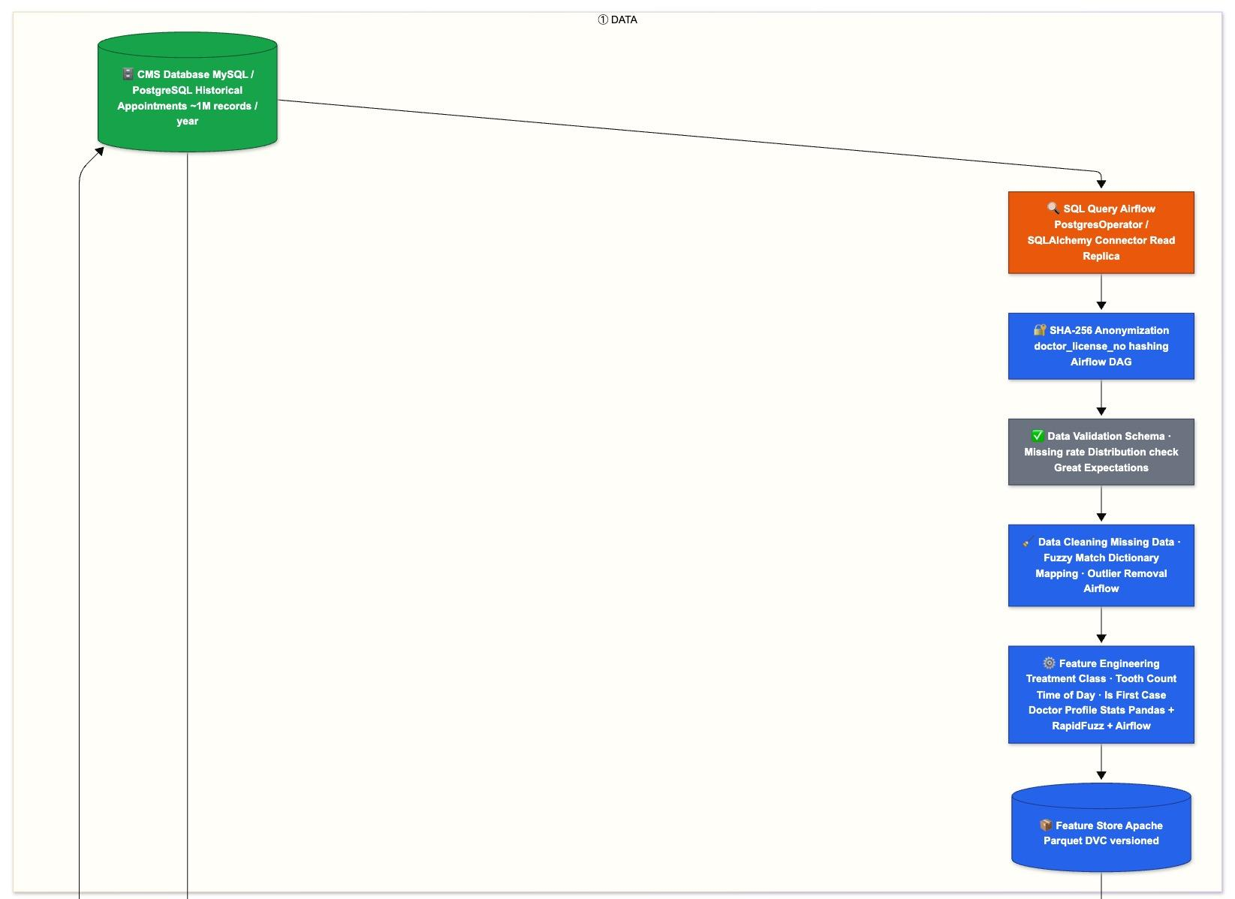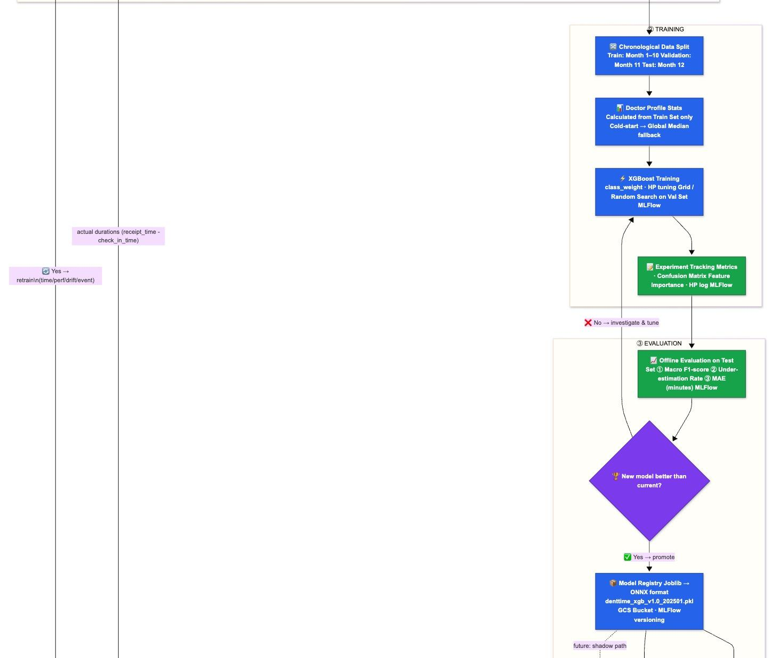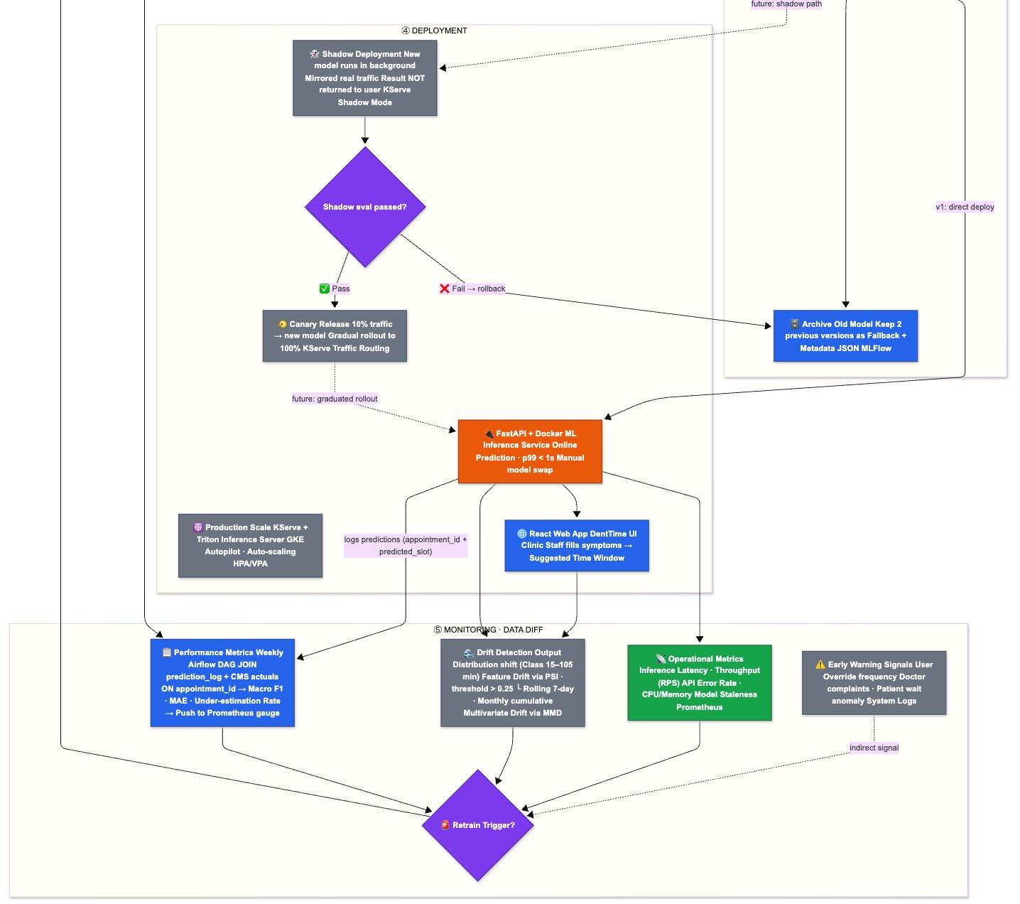

2. Automation Improvement Roadmap
To transition from a manual/semi-automated state to a mature MLOps environment, several components have been identified for targeted automation improvements.
Phase | Component | Current Status | Current Pain Point | Proposed Full Automation
① DATA | SQL Query | 🟠 Manual | Humans must manually trigger extraction. No scheduling. | Schedule Airflow DAG (e.g., nightly). Add event-based triggers via Airflow Sensor for new CMS records.
① DATA | SHA-256 Anonymization | 🔵 Semi-Auto | Code requires manual edits if schema changes. No schema-drift detection. | Integrate schema introspection step in DAG. Auto-detect PII via metadata tags.
① DATA | Data Cleaning | 🔵 Semi-Auto | Normalization dictionary and outlier thresholds require manual updates. | Build auto-expanding dictionary via RapidFuzz and versioned lookup.
④ DEPLOY | Inference Service | 🟠 Manual | Requires manual swapping of model files and container restarts. | Implement rolling model hot-swap: Service polls Registry/GCS and loads new model in-memory.
④ DEPLOY | React Web App | 🔵 Semi-Auto | UI deployment requires manual build/push steps. No automated integration tests. | Add CI/CD (GitHub Actions) to auto-build/deploy on merge. Add automated smoke tests for API.
⑤ MONITOR | Performance Metrics | 🔵 Semi-Auto | Weekly DAG needs manual join config updates. Thresholds require manual tuning. | Fully automate JOIN via dynamic query templates. Auto-alert on metric drops. Programmatic retrain trigger.

3. Data Diff and Drift Detection Strategy
To guarantee the reliability of predictions over time, the system uses a four-layered drift detection approach to automatically flag statistical divergences without immediately requiring ground-truth labels.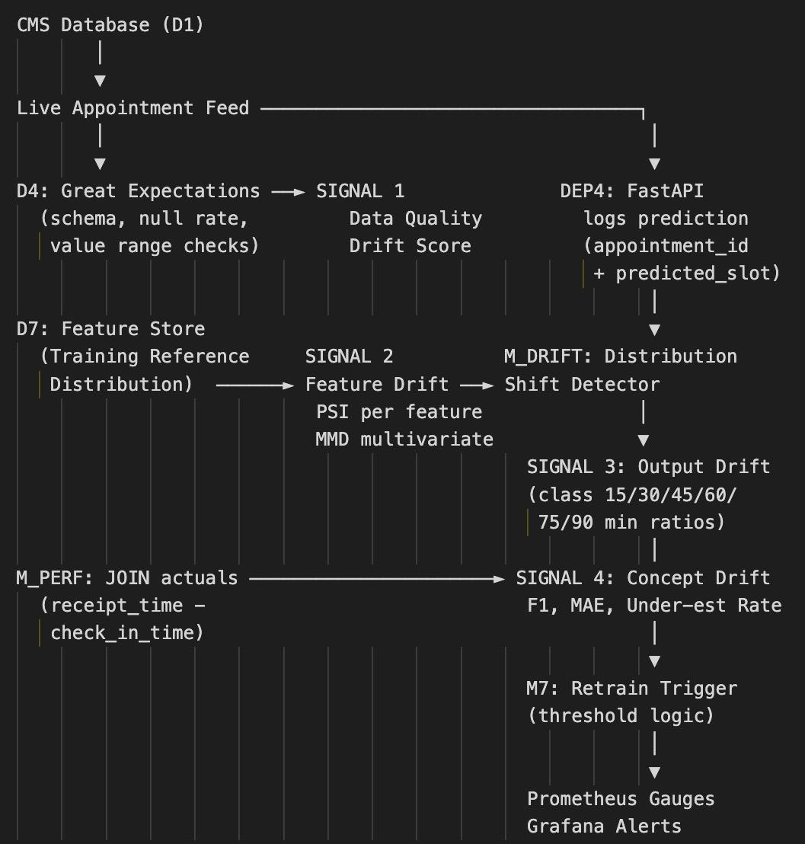

The Four Drift Signals

- Signal 1: Data Quality Drift (Data Validate Scheme): Evaluated per batch using Great Expectations to catch structural data anomalies immediately.
- Signal 2: Feature Drift (PSI): Computes Population Stability Index comparing the feature store feed against live incoming data on a rolling 7-day window.
- Signal 3: Output Distribution: Tracks prediction shifts across the 6 treatment-duration classes (15–105 min) using Pandas and Prometheus on a daily basis.
- Signal 4: Concept Drift (M_PERF): Measures true degradation in model accuracy (F1, MAE, Under-estimation) by joining predictions with actual completed appointment times. Computed weekly via Airflow.

Key Architectural Trade-offs
- PSI vs. MMD (Maximum Mean Discrepancy): We use PSI for individual features because it is highly interpretable—crucial for explaining shifts to clinical stakeholders. While MMD captures multivariate shifts more rigorously, it functions as a "black box." Therefore, the strategy utilizes PSI for explainable, per-feature alerting, backed by MMD as a monthly multivariate safety net.
- Latency Tolerances: Concept drift (Signal 4) naturally lags due to the wait time between scheduling and appointment completion. Since the clinic operates on daily/weekly cycles, millisecond latency for drift scoring is unnecessary. Batch drift evaluation handles the requirements efficiently.

3. Deployment Model: Current vs. Future
The pipeline is intentionally structured to launch with a high-control, manual mechanism and systematically evolve into an automated, highly scalable Kubernetes architecture.

3.1 Current State: v1 Direct Deploy
In v1, models are deployed directly to a single FastAPI + Docker container. Model swapping is a manual process requiring an engineer to replace the .pkl artifact and restart the service.
- Rationale: For safety-sensitive clinical scheduling, a human-in-the-loop ensures that unexpected behaviors are caught. This provides strict audit trails while targeting online predictions under 1 second.

3.2 Future State: Progressive Safe Deployment
The future architecture removes the human bottleneck while increasing safety through automation.
- Step 1 - KServe Shadow Mode: New models run parallel to production models. Incoming traffic is duplicated, but the new model's predictions are only logged (not returned to the user), allowing zero-risk evaluation against live data.
- Step 2 - Canary Release: Traffic is routed dynamically (10% → 25% → 50% → 100%). Progression halts and automatically rolls back if performance metrics (like the Under-Estimation Rate) degrade.
- Step 3 - Production Scale: The service migrates from a standalone container to KServe + Triton Inference Server on GKE Autopilot. This activates Horizontal and Vertical Pod Autoscaling (HPA/VPA), eliminating manual capacity planning.

3.3 Deployment Summary Comparison
Dimension | Current (v1) | Future (Target)
Deployment Trigger | Manual model swap | Automated (post-shadow pass)
Traffic Safety | Full traffic receives new model | Shadow → Canary (Gradual Rollout)
Rollback Speed | Manual container restart | Automatic KServe traffic rerouting
Scalability | Single Docker container | GKE Autopilot with HPA / VPA
Model Format | Joblib (.pkl) | ONNX (Triton-compatible)
Drift Monitoring | Not implemented natively | PSI + MMD via Prometheus / Grafana
Retraining | Scheduled / Manual | Automated trigger (Drift/Performance/Event)

